Frontend Development with React.js Project Documentation for FitFlex

- Introduction
  - Project Title : Insight Stream : FitFlex
  - Team Members:
Subash B(Team Leader) [Email Id: bpsubash@gmail.com ]
Tharun G [Email Id: Tharunshankar34@gmail.com ]
Sugumar SA [Email Id: sukumarpalani5@gmail.com ]
VasanthaKumar I [Email Id: vasanthvkvdr07@gmail.com ]
Veeraprabu T [Email Id: veeraprabup226@gmail.com ]

Project Overview
  - Purpose:
SB Fitzz is a user-friendly fitness app designed to simplify exercise discovery and engagement. It provides a seamless platform for users to explore, manage, and personalize their workout routines with ease.

Features:
    - Exercise Library – Access diverse workouts from trusted fitness APIs..
    - Advanced Search – Find exercises by category, muscle group, or equipment..
    - Visual Exploration – Browse workouts with images and videos..
    - User-Friendly UI – Clean, modern, and intuitive design.Newsletter Subscription: Keeps users updated with personalized news..
    - YouTube Integration – View related exercise tutorials.

Architecture
  - Component Structure:
The application is built using React.js with a component-based architecture. Major components include:

    - Components/ – Reusable UI (Navbar, SearchBar, ExerciseCard, Footer).
    - Pages/ – Main screens (Home, Categories, ExerciseDetails).
    - Styles/ – CSS/Tailwind for styling.

State Management:
- Uses React Hooks (useState, useEffect).
- Context API for global state (exercise data).

Routing:
The application uses React Router for navigation. Routes include:
    - / → Home Page
    - /categories → Categories Page
    - /exercise/:id → Exercise Details Page

Setup Instructions
  - Prerequisites:
    - Node.js (v16 or higher)
    - npm (v8 or higher)
    - Git

Installation:
- Clone the repository git clone <repository-url>cd fitflex-app-react
- Navigate to the client directory:
- Install dependencies: npm install
- Configure environment variables: Create a .env file in the client directory and add the necessary variables (e.g., API keys).
- Start the development server: npm start

Folder Structure
  - Src/Source

components/ → Reusable UI elements (Navbar, SearchBar, ExerciseCard, Footer)

pages/ → Screens (Home, Categories, ExerciseDetails)

styles/ → Styling files (CSS/Tailwind)

api.js → Handles API calls (Axios).

App.js & index.js – Core React files.

App.js → Main application file

index.js → Entry point.

Running the Application Frontend:
- To start the frontend server, run the following command in the client directory: npm start
- npm install
- npm start
- The application will be available at http://localhost:3000

Component Documentation
  - Key Components:
- Navbar.js – Navigation bar with links to Home, Categories, and Search.
- SearchBar.js – Allows users to search for exercises dynamically.
- ExerciseCard.js – Displays exercise name, image, and category.
- CategoryFilter.js – Filters exercises based on category..

- Footer.js – Displays social links and branding
- Home.js – Shows featured exercises and intro.

State Management

React Hooks – Uses useState and useEffect f

Global State (Context API) – Manages exercise data across components..

Implements Context API – Provides global state management for exercises.

Handles User Interactions – Updates state for search, filters, and navigation.

Optimized for Performance – Minimizes unncessary re-renders with efficient state handling.

User Interface
  - Screenshots
    - Home Page: Display featured tracks and FitFlex.

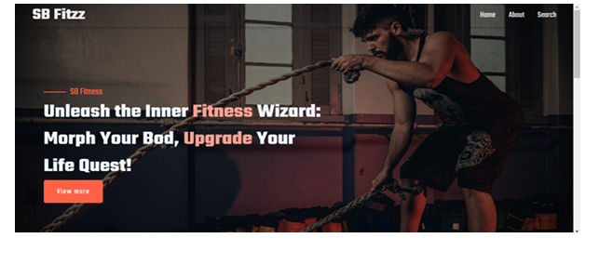

    - Search Page: Allows users to search for body parts etc.

    - 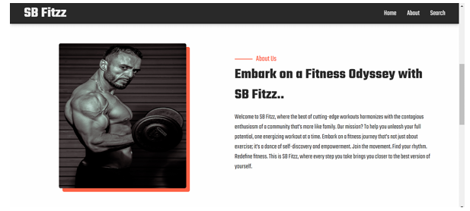
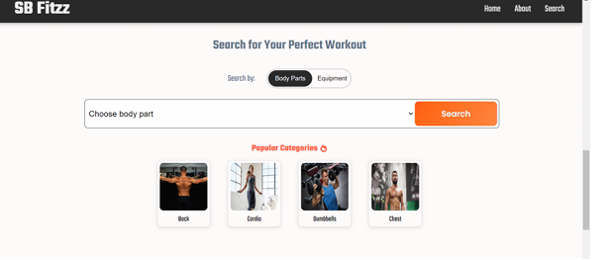

Styling
  - CSS Frameworks/Libraries:
The application uses Styled-Components for styling. This allows for modular and scoped CSS within components.

Theming:
A custom theme is implemented using Styled-Components, with support for light and dark modes.

Testing
  - Testing Strategy:
    - Unit Testing: Using Jest and React Testing Library.
    - Integration Testing: Is performed to ensure that components work together as expected.
    - End-to-End Testing: Cypress is used for end-to-end testing of user flows.

Code Coverage:
    - Code coverage is monitored using Jest’s built in coverage tool. The current coverage is 85%.

Screenshots or Demo
  - Demo Link: https://drive.google.com/file/d/15McBojzsT0cbjUsMdYeIbQzrgsBM-6fG/view?usp=drivesdk
  - Screenshots: See section 9 for UI screenshots.

Known Issues
  - Issue 1: Slow API Response – Exercise data may load slowly due to external API rate limits. 🔄 Solution: Implement caching and optimize API calls.
  - Issue 2: Some exercises may not appear due to incomplete keyword matching. 🔍 Solution: Improve search algorithm with fuzzy matching.

Future Enhancements
  - Future Features:
    - User Authentication – Allow users to create accounts, save workouts, and track progress.
    - Personalized Workout Plans – Generate AI-powered exercise routines based on user goals.
    - Offline Mode – Allow users to access saved workouts without an internet connection.
    - Community & Social Features – Enable users to share workouts, comment, and interact.

This documentation provides a comprehensive overview of the FitFlex project, including its architecture, setup instructions, and future plans.

